
Experiment 8: Implementation of SVM, KNN, and Neural Network (NN)
AIM:
To implement and evaluate different supervised machine learning algorithms — Support Vector Machine (SVM), K-Nearest Neighbors (KNN), and Neural Network (NN) — using built-in datasets and analyze their performance.

DESCRIPTION:
This experiment demonstrates the working and evaluation of three fundamental supervised learning algorithms:
- SVM (Support Vector Machine) — constructs an optimal hyperplane to classify data points with maximum margin using kernels for non-linear separations.
- KNN (K-Nearest Neighbors) — classifies data based on the majority vote of the nearest ‘k’ training samples.
- Neural Network (NN) — mimics the brain’s neuron connections using multiple layers to learn complex non-linear relationships.
The experiment uses the Digits dataset from Scikit-learn. Data preprocessing involves standardization and train-test splitting. Models are trained, evaluated using cross-validation, and assessed based on Precision, Recall, F1-Score, and Accuracy. Performance is visualized through learning curves and confusion matrices.

SYSTEM REQUIREMENTS:
- Minimum 4 GB RAM (8 GB recommended)
- Python 3.7 or higher
- Libraries: numpy, scikit-learn, tensorflow, matplotlib, seaborn
- IDE: Jupyter Notebook / Google Colab / VS Code

ALGORITHM / PROCEDURE:
- Import Libraries – Load required modules from Scikit-learn, TensorFlow, and supporting libraries.
- Load Dataset – Use the built-in load_digits() dataset.
- Preprocess Data – Standardize features using StandardScaler. For NN, apply one-hot encoding to labels.
- Split Data – Divide dataset into 80% training and 20% testing.
- Model Initialization:
  - SVM: SVC(kernel='rbf')
  - KNN: KNeighborsClassifier(n_neighbors=5)
  - NN: Sequential(Dense layers with ReLU and softmax)
- Model Training & Validation – Train models and perform 5-fold cross-validation for SVM and KNN.
- Prediction & Evaluation – Predict on test data and compute Precision, Recall, and F1-Score.

- Visualization – Plot learning curves and confusion matrices for performance comparison.
- Display Outputs – Print metrics and visualize model accuracies.

CODE (Simplified Combined):
# ============================================================
# 🧠 Implementation of SVM, KNN, and Neural Network with Visualization
# ============================================================

import numpy as np
import matplotlib.pyplot as plt
import seaborn as sns
from sklearn.datasets import load_wine
from sklearn.model_selection import train_test_split, cross_val_score
from sklearn.preprocessing import StandardScaler
from sklearn.metrics import precision_score, recall_score, f1_score, confusion_matrix, accuracy_score
from sklearn.svm import SVC
from sklearn.neighbors import KNeighborsClassifier
from tensorflow.keras.models import Sequential
from tensorflow.keras.layers import Dense, Dropout
from tensorflow.keras.utils import to_categorical
from tensorflow.keras.optimizers import Adam

# ==========================
# 📊 Load and Preprocess Data
# ==========================
data = load_wine()
X, y = data.data, data.target

# Split dataset
X_train, X_test, y_train, y_test = train_test_split(X, y, test_size=0.2, random_state=42, stratify=y)

# Feature Scaling
scaler = StandardScaler()
X_train = scaler.fit_transform(X_train)
X_test = scaler.transform(X_test)

# ==========================
# ⚙️ 1. Support Vector Machine (SVM)
# ==========================
svm = SVC(kernel='rbf', C=1.0, gamma='scale')
cv_svm = cross_val_score(svm, X_train, y_train, cv=5, scoring='accuracy')

svm.fit(X_train, y_train)
y_pred_svm = svm.predict(X_test)

# ==========================
# ⚙️ 2. K-Nearest Neighbors (KNN)
# ==========================
knn = KNeighborsClassifier(n_neighbors=5)
cv_knn = cross_val_score(knn, X_train, y_train, cv=5, scoring='accuracy')
knn.fit(X_train, y_train)
y_pred_knn = knn.predict(X_test)

# ==========================
# ⚙️ 3. Neural Network (NN)
# ==========================
y_train_nn, y_test_nn = to_categorical(y_train), to_categorical(y_test)

nn = Sequential([
Dense(64, activation='relu', input_shape=(X_train.shape[1],)),
Dense(32, activation='relu'),
Dropout(0.3),
Dense(3, activation='softmax')
])
nn.compile(optimizer=Adam(learning_rate=0.001), loss='categorical_crossentropy', metrics=['accuracy'])
history = nn.fit(X_train, y_train_nn, epochs=30, batch_size=16, validation_split=0.1, verbose=0)
y_pred_nn = np.argmax(nn.predict(X_test), axis=1)

# ==========================
# 📈 Model Evaluation
# ==========================
models = {
'SVM': (y_test, y_pred_svm, cv_svm),
'KNN': (y_test, y_pred_knn, cv_knn),
'Neural Network': (y_test, y_pred_nn, None)
}

results = []

for name, (y_true, y_pred, cv) in models.items():
precision = precision_score(y_true, y_pred, average='weighted')
recall = recall_score(y_true, y_pred, average='weighted')


f1 = f1_score(y_true, y_pred, average='weighted')
acc = accuracy_score(y_true, y_pred)
cv_acc = cv.mean() if cv is not None else np.nan

results.append([name, acc, precision, recall, f1, cv_acc])

# Confusion Matrix
cm = confusion_matrix(y_true, y_pred)
plt.figure(figsize=(5, 4))
sns.heatmap(cm, annot=True, fmt='d', cmap='Blues', xticklabels=data.target_names, yticklabels=data.target_names)
plt.title(f'Confusion Matrix - {name}')
plt.xlabel('Predicted Label')
plt.ylabel('True Label')
plt.show()

# ==========================
# 📊 Compare Model Performance
# ==========================
import pandas as pd
df_results = pd.DataFrame(results, columns=['Model', 'Accuracy', 'Precision', 'Recall', 'F1-Score', 'CV Accuracy'])
print("\nModel Performance Summary:\n", df_results.round(4))

# Bar plot comparison
plt.figure(figsize=(8, 5))
sns.barplot(x='Model', y='Accuracy', data=df_results)
plt.title('Model Accuracy Comparison')
plt.ylabel('Accuracy')
plt.show()

# ==========================
# 🧠 Neural Network Training Curves
# ==========================
plt.figure(figsize=(12, 5))
plt.subplot(1, 2, 1)
plt.plot(history.history['accuracy'], label='Train Accuracy', marker='o')
plt.plot(history.history['val_accuracy'], label='Validation Accuracy', marker='o')
plt.title('NN Accuracy Curve')
plt.xlabel('Epochs')
plt.ylabel('Accuracy')

plt.legend()
plt.subplot(1, 2, 2)
plt.plot(history.history['loss'], label='Train Loss', marker='o')
plt.plot(history.history['val_loss'], label='Validation Loss', marker='o')
plt.title('NN Loss Curve')
plt.xlabel('Epochs')
plt.ylabel('Loss')
plt.legend()
plt.show()

OUTPUT (Summary):
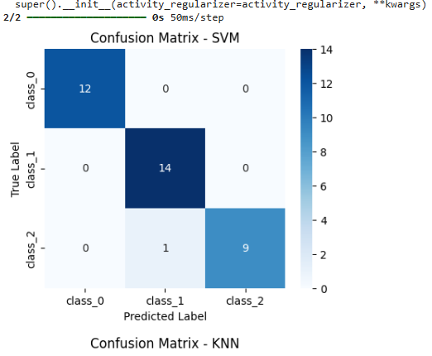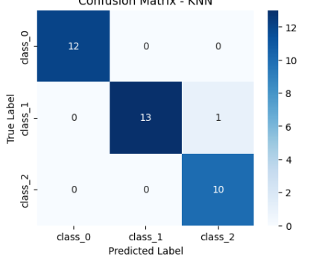

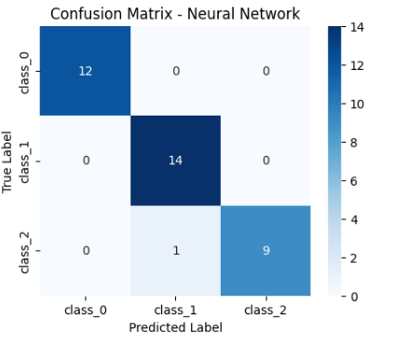

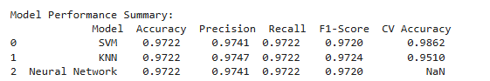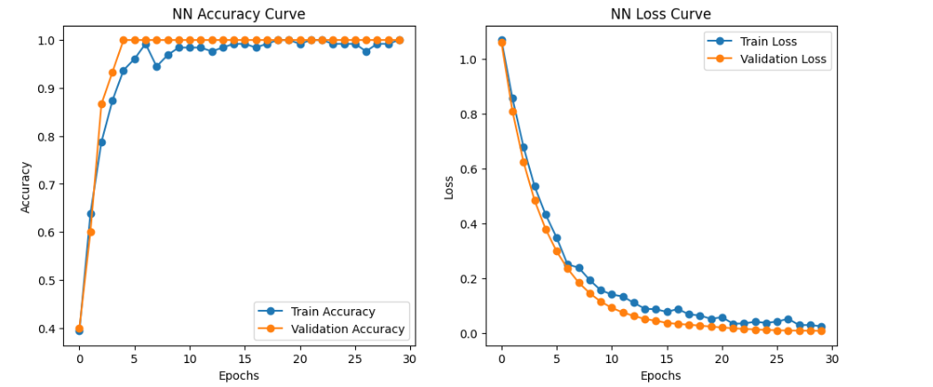


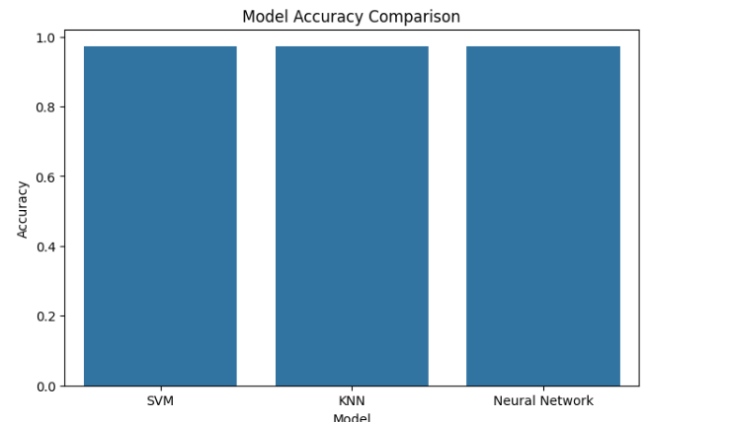



AIM:
To develop and evaluate machine learning models — Support Vector Machine (SVM), K-Nearest Neighbors (KNN), and Decision Tree — for predicting whether a tumor is benign or malignant using the Breast Cancer Wisconsin dataset.

DESCRIPTION:
Breast cancer is one of the most common cancers among women, and early detection can significantly improve survival rates.
This experiment demonstrates the use of supervised learning algorithms to automatically classify tumors based on diagnostic features such as cell size, uniformity, texture, and nucleus shape.
The algorithms used include:
- SVM (Support Vector Machine): Finds the optimal separating hyperplane between classes.
- KNN (K-Nearest Neighbors): Classifies a tumor based on the majority label of its k nearest samples.
- Decision Tree: Creates a tree structure that splits data based on feature importance for classification.
By comparing these models, we identify which algorithm provides the best diagnostic accuracy and interpretability.

PROCEDURE:
- Import necessary libraries and modules.
- Load the Breast Cancer dataset from Scikit-learn.
- Split the dataset into training (80%) and testing (20%) sets.
- Standardize feature values using StandardScaler for uniform scaling.
- Train three classifiers — SVM, KNN, and Decision Tree.
- Predict and evaluate the results using metrics: Accuracy, Precision, Recall, and F1-score.
- Visualize confusion matrices and a comparison chart of model accuracies.
- Display the Decision Tree structure for interpretability.
CODE:
# ============================================================
# Breast Cancer Classification using SVM, KNN & Decision Tree
# ============================================================

import numpy as np
import matplotlib.pyplot as plt
import seaborn as sns
import pandas as pd

from sklearn.datasets import load_breast_cancer
from sklearn.model_selection import train_test_split, cross_val_score
from sklearn.preprocessing import StandardScaler
from sklearn.metrics import accuracy_score, precision_score, recall_score, f1_score, confusion_matrix
from sklearn.svm import SVC
from sklearn.neighbors import KNeighborsClassifier
from sklearn.tree import DecisionTreeClassifier, plot_tree

# ==============================
# 📊 Load and Preprocess Dataset
# ==============================
data = load_breast_cancer()
X, y = data.data, data.target

# Split into training and testing sets
X_train, X_test, y_train, y_test = train_test_split(X, y, test_size=0.2, random_state=42, stratify=y)

# Standardize features
scaler = StandardScaler()
X_train = scaler.fit_transform(X_train)
X_test = scaler.transform(X_test)

# ==============================
# ⚙️ Train Models
# ==============================

# Support Vector Machine
svm = SVC(kernel='rbf', gamma='scale')
svm.fit(X_train, y_train)
y_pred_svm = svm.predict(X_test)

# K-Nearest Neighbors
knn = KNeighborsClassifier(n_neighbors=7)
knn.fit(X_train, y_train)
y_pred_knn = knn.predict(X_test)

# Decision Tree
tree = DecisionTreeClassifier(criterion='entropy', random_state=42, max_depth=4)
tree.fit(X_train, y_train)
y_pred_tree = tree.predict(X_test)


# ==============================
# Evaluate Models
# ==============================
models = {
"SVM": (y_test, y_pred_svm),
"KNN": (y_test, y_pred_knn),
"Decision Tree": (y_test, y_pred_tree)
}

results = []
for name, (y_true, y_pred) in models.items():
acc = accuracy_score(y_true, y_pred)
prec = precision_score(y_true, y_pred, average='weighted')
rec = recall_score(y_true, y_pred, average='weighted')
f1 = f1_score(y_true, y_pred, average='weighted')
results.append([name, acc, prec, rec, f1])

# Confusion Matrix
plt.figure(figsize=(5, 4))
sns.heatmap(confusion_matrix(y_true, y_pred), annot=True, fmt='d', cmap='Purples',
xticklabels=data.target_names, yticklabels=data.target_names)
plt.title(f"Confusion Matrix - {name}")
plt.xlabel("Predicted")
plt.ylabel("True")
plt.show()

# ==============================
# Model Comparison
# ==============================
df = pd.DataFrame(results, columns=["Model", "Accuracy", "Precision", "Recall", "F1-Score"])
print("\nModel Performance Summary:\n")
print(df.round(4))

plt.figure(figsize=(7, 4))
sns.barplot(x="Model", y="Accuracy", data=df, palette="plasma")
plt.title("Model Accuracy Comparison")
plt.show()

# ==============================
# Decision Tree Visualization

# ==============================
plt.figure(figsize=(14, 8))
plot_tree(tree, filled=True, feature_names=data.feature_names, class_names=data.target_names)
plt.title("Decision Tree Structure")
plt.show()

OUTPUT (Sample):

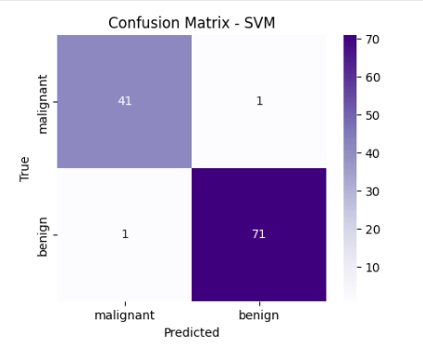
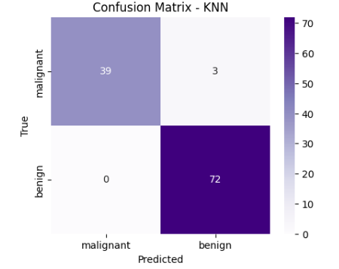


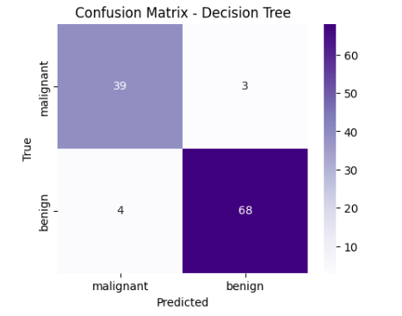
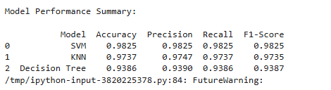

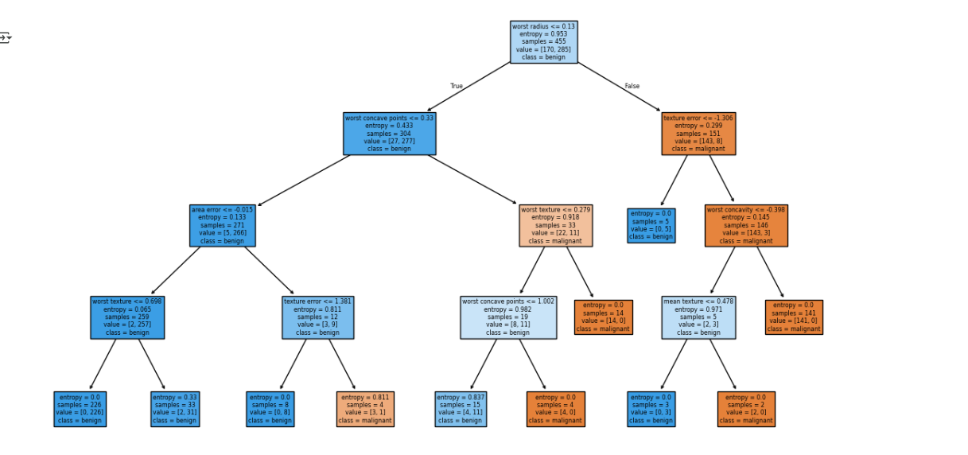


Experiment: Demonstration of clustering algorithms — k-Means, Agglomerative, DBSCAN
AIM
To implement and compare the performance of k-Means, Agglomerative (hierarchical) and DBSCAN clustering algorithms on a standard dataset, and visualize cluster assignments after dimensionality reduction.

DESCRIPTION
Clustering groups similar data points without labels (unsupervised learning). This experiment uses the Iris dataset to demonstrate three popular clustering techniques:
- k-Means: partitions data into k clusters by minimizing within-cluster variance.
- Agglomerative Clustering: a bottom-up hierarchical method that merges clusters based on linkage criteria. A dendrogram shows the tree.
- DBSCAN: density-based clustering that finds arbitrarily shaped clusters and marks noise (outliers).
We will preprocess with scaling, reduce to 2D with PCA for plotting, compute internal validation metrics (Silhouette score, Davies-Bouldin), and — for reference only — compare clusters to true labels using Adjusted Rand Index (ARI).

PROCEDURE
- Import libraries.
- Load Iris dataset.
- Scale features (StandardScaler).
- Reduce dimensions to 2 using PCA (for plotting).
- Run k-Means (k=3), Agglomerative (n_clusters=3, linkage='ward'), and DBSCAN (eps/min_samples tuned).
- Compute Silhouette score, Davies-Bouldin index for each method.
- Compute Adjusted Rand Index (ARI) against ground truth (reference metric only).
- Plot 2D scatter (PCA) colored by cluster for each algorithm and show dendrogram for Agglomerative.
- Summarize results in a small table.

CODE
# Clustering demo: k-Means, Agglomerative, DBSCAN on Iris
import numpy as np
import pandas as pd
import matplotlib.pyplot as plt
import seaborn as sns

from sklearn.datasets import load_iris
from sklearn.preprocessing import StandardScaler
from sklearn.decomposition import PCA

from sklearn.cluster import KMeans, AgglomerativeClustering, DBSCAN
from sklearn.metrics import silhouette_score, davies_bouldin_score, adjusted_rand_score
from scipy.cluster.hierarchy import dendrogram, linkage

# --- Load data ---
iris = load_iris()
X = iris.data
y_true = iris.target
feature_names = iris.feature_names
target_names = iris.target_names

# --- Preprocessing ---
scaler = StandardScaler()
X_scaled = scaler.fit_transform(X)

# --- PCA for 2D visualization ---
pca = PCA(n_components=2, random_state=42)
X_pca = pca.fit_transform(X_scaled)

# --- Clustering algorithms ---
# 1) k-Means
kmeans = KMeans(n_clusters=3, random_state=42)
labels_kmeans = kmeans.fit_predict(X_scaled)

# 2) Agglomerative (Ward linkage)
agglo = AgglomerativeClustering(n_clusters=3, linkage='ward')
labels_agglo = agglo.fit_predict(X_scaled)

# 3) DBSCAN (eps chosen empirically for Iris scaled data)
dbscan = DBSCAN(eps=0.9, min_samples=5) # eps may be adjusted
labels_dbscan = dbscan.fit_predict(X_scaled)

# --- Evaluation metrics ---
def evaluate(labels, name):
# handle case where DBSCAN labels may be single cluster or all noise
unique_labels = np.unique(labels)
if len(unique_labels) <= 1 or (len(unique_labels) == 2 and -1 in unique_labels and len(unique_labels)==1):
sil = np.nan
db = np.nan
else:
sil = silhouette_score(X_scaled, labels)

db = davies_bouldin_score(X_scaled, labels)
ari = adjusted_rand_score(y_true, labels)
return {'method': name, 'n_clusters': len(set(labels)) - (1 if -1 in labels else 0),
'silhouette': sil, 'davies_bouldin': db, 'ARI_vs_true': ari}

results = []
results.append(evaluate(labels_kmeans, 'k-Means'))
results.append(evaluate(labels_agglo, 'Agglomerative'))
results.append(evaluate(labels_dbscan, 'DBSCAN'))

# --- Plotting: PCA scatter for each clustering result ---
plt.figure(figsize=(15,4))
methods = [('k-Means', labels_kmeans), ('Agglomerative', labels_agglo), ('DBSCAN', labels_dbscan)]
for i, (name, labels) in enumerate(methods, 1):
plt.subplot(1,3,i)
palette = sns.color_palette('tab10', np.unique(labels).size)
# map -1 to color for DBSCAN noise
sns.scatterplot(x=X_pca[:,0], y=X_pca[:,1], hue=labels, palette=palette, legend='full', s=60)
plt.title(f'{name} (PCA space)')
plt.xlabel('PC1'); plt.ylabel('PC2')
plt.legend(title='cluster', bbox_to_anchor=(1.05, 1), loc='upper left')
plt.tight_layout()
plt.show()

# --- Dendrogram for Agglomerative (use linkage on scaled data) ---
linked = linkage(X_scaled, method='ward')
plt.figure(figsize=(10, 5))
dendrogram(linked, labels=iris.target, leaf_rotation=90., leaf_font_size=8., color_threshold=0.0)
plt.title('Hierarchical Clustering Dendrogram (Ward)')
plt.xlabel('Sample index or (class label)')
plt.ylabel('Distance')
plt.show()

# --- Summary table ---
df_res = pd.DataFrame(results)
display(df_res.round(4))

# Also show confusion-like mapping counts for reference (clusters vs true labels)
print("\nContingency tables (clusters vs true labels):\n")

for name, labels in methods:
ct = pd.crosstab(labels, y_true, rownames=['cluster'], colnames=['true_label'])
print(f"--- {name} ---")
display(ct)

OUTPUT
